**ISLAB**



**Session 2023-2027**

**Submitted by:**

Sumaira Hafeez 2023-CS-1

**Supervised by:**

Mam Faiza Iqbal

**Course:**

Information Security

Department of Computer Science

**University of Engineering and Technology**

**Lahore Pakistan**

## **Lab11: Veracrypt configuration**

## **Creating Hidden VeraCrypt file:**

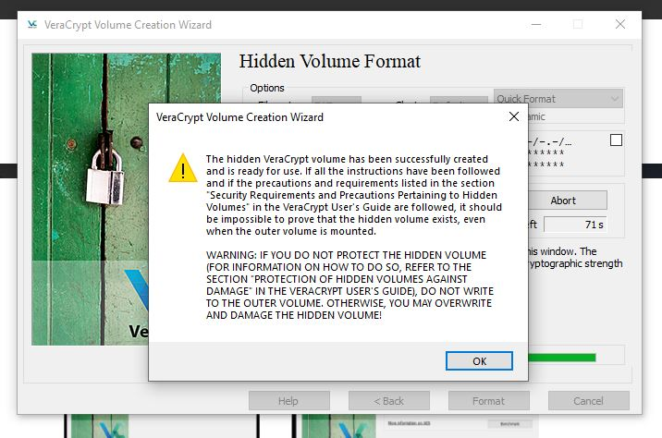

## **Mounting Hidden VeraCrypt file:**

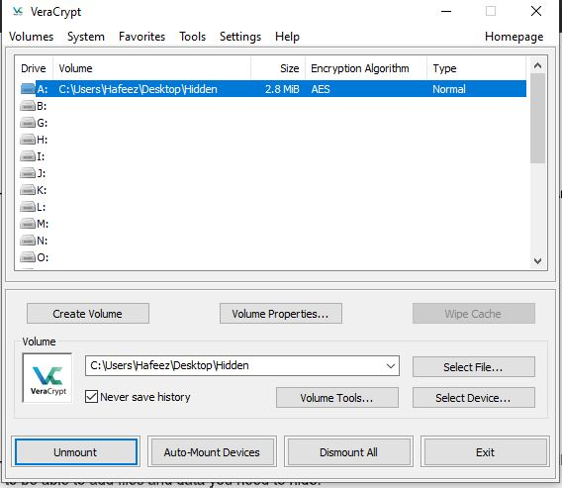

## **Creating Encrypted USB:**

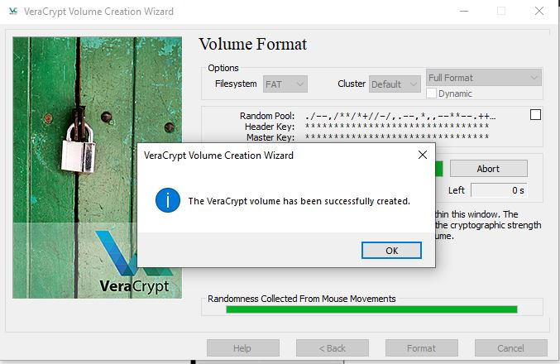

**RESULT**

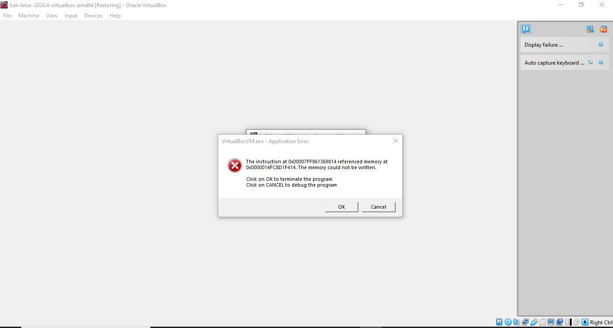

## **Creating Outer Volume:**

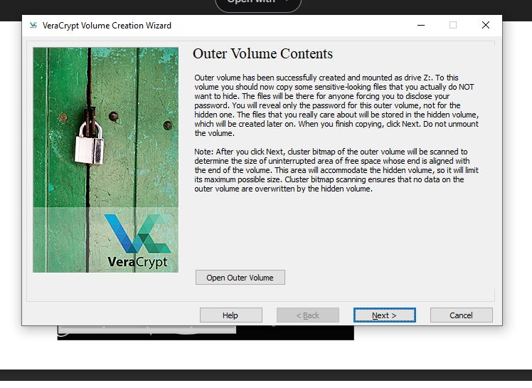

## **Output Mounted:**

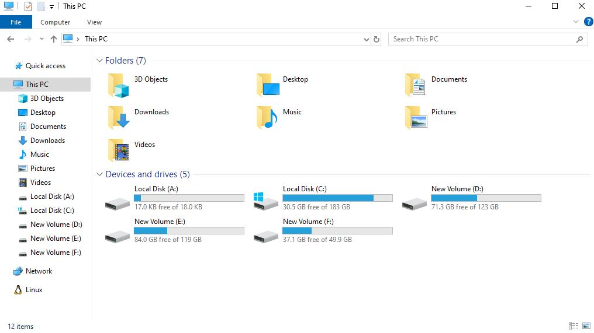

## **Output unmounted:**

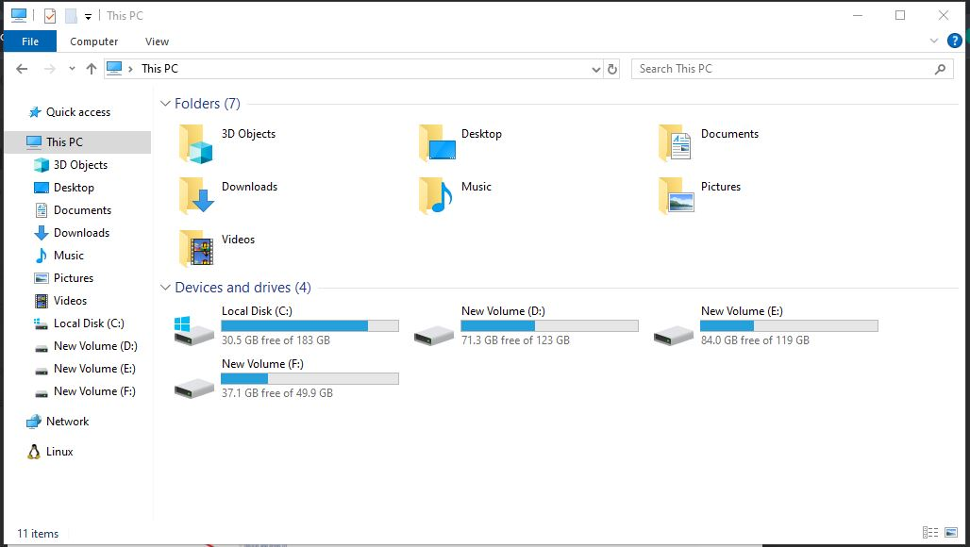

## **Lab12: RSA Encryption-Decryption:**

**Generating key:**

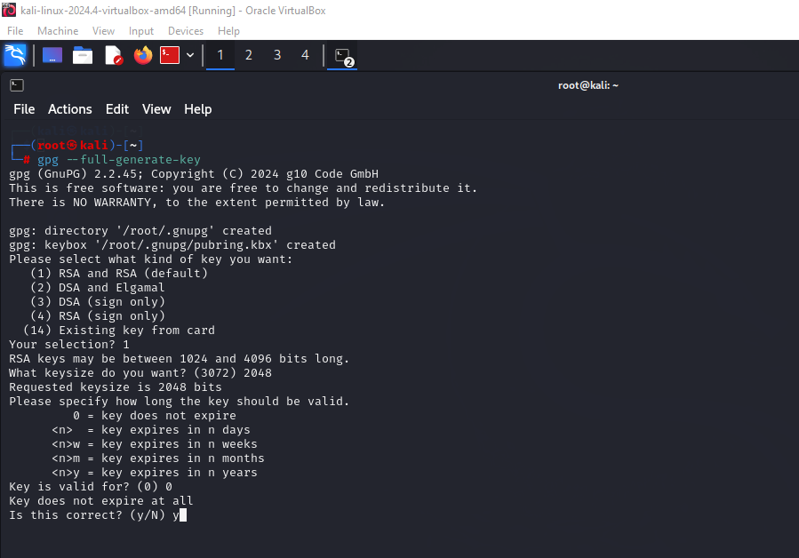

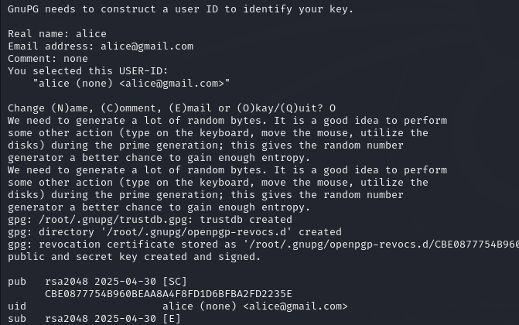

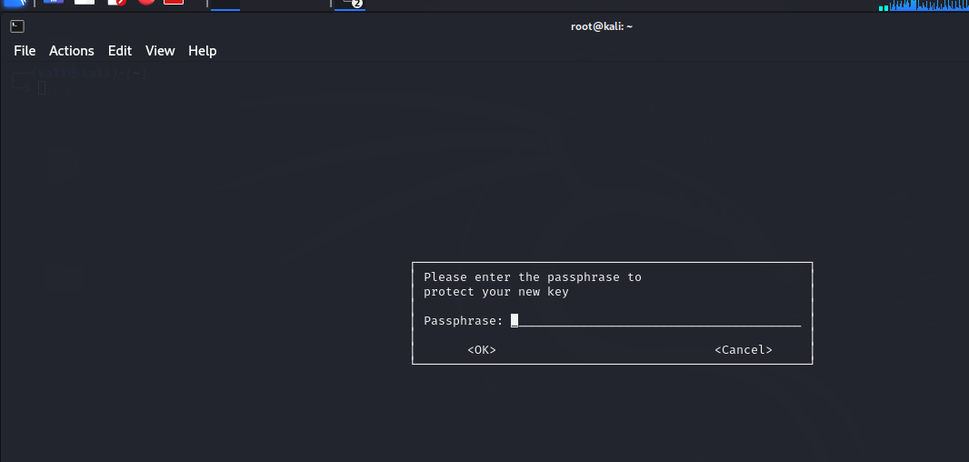

**Creating and encrypt file:**

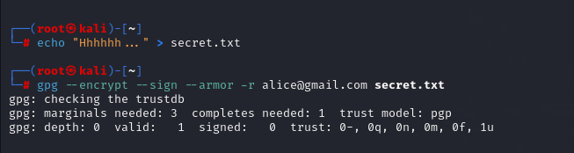

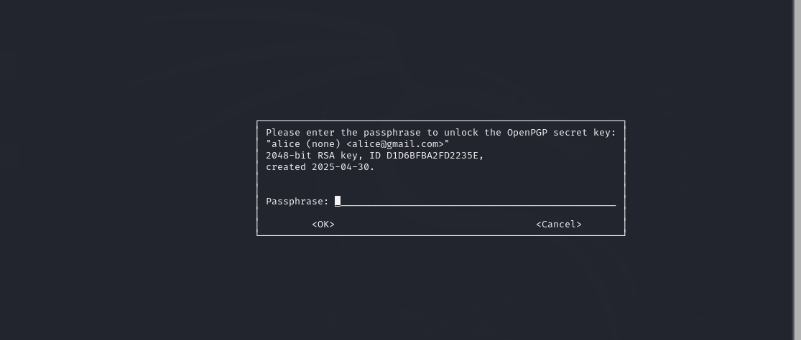

**Sending file:**

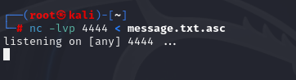

**Decrypt File:**

